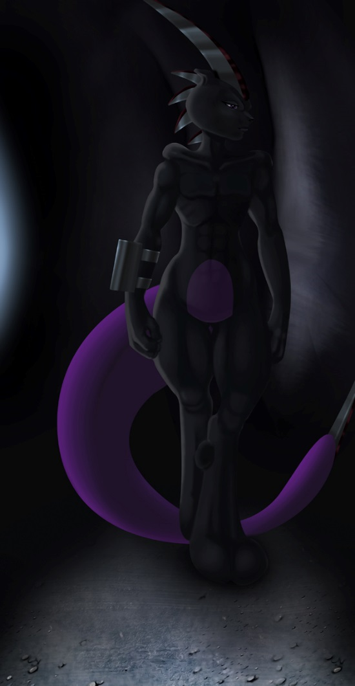
War Maiden's Lament

The visage of an end day
What hath ended was but the fall with each drop
Life bleeding from the fingertips of the fallen
More that bleeds from the eyes of the one
Silent, invisible, unseen, unshed tears
Feelings laced with iron weights
Gauges that find their means around the heart
Not the ventricle, but the honor ridden part that beats
Metaphysical weights that shall remain
Never will there be an end for what has been done
Instead carrying their weight
For every lost one is thee to be remembered
Know thyself well from within
If only she will be sure to remember
For thine image is Mewblade.

~Quentix Starwing

